Plant Tissue System
A tissue is a cluster of cells, that are alike in configuration and work together to attain a specific function. Different types of plant tissues include permanent and meristematic tissues.

*Meristematic tissue:
These tissues have the capability to develop by swift division. They assist in the major growth of the vegetation. Growth in length and growth in diameter of the plant is carried about by these cells. The Meristematic cells are cubical, living cells with a big nucleus. These cells are meticulously crammed with no intercellular spaces. Depending on the section where the meristematic tissues are existing, they are categorized as intercalary, lateral and apical meristems.

Types of Meristematic Tissue
Meristematic tissues are of three types, based on their location in plants. They are:

Apical Meristems
They are found at the tips of roots and stems, enabling a plant to extend in length.

Lateral Meristems
They are found on the lateral side of the stem and root of a plant, facilitating growth in thickness or girth.

Intercalary Meristems
They occur only at the bases of leaf blades and nodes of monocots. These help the plant to increase in length from the leaf base.
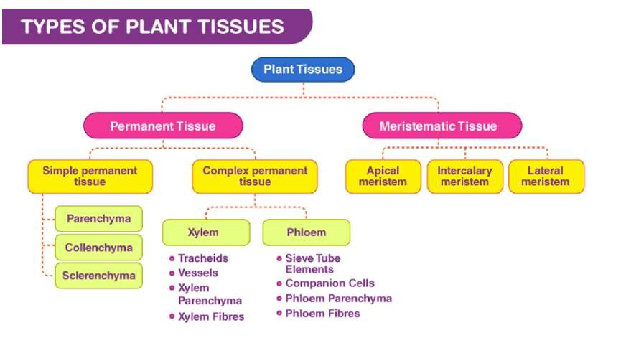

Permanent tissues:
These cells have lost their ability to distribute but are specialised to offer elasticity, flexibility and strength to the plant. These tissues can be additionally categorised into:
Simple Permanent Tissue: They can be classified into sclerenchyma, collenchyma and parenchyma based on their purpose.
Complex Permanent Tissue: These tissues include phloem and xylem. Xylem is valuable for the transportation of water and solvable constituents. It is made up of xylem parenchyma, fibres, vessels and tracheids. Phloem is valuable in the transportation of food particles. Phloem consists of phloem parenchyma, phloem fibers, companion cells, sieve cells and sieve tubes.

Types of Permanent Tissue
When meristem cells differentiate and become specialized, they lose their availability to divide and form nonmeristematic or permanent tissue. Such cells assume specific roles and lose their ability to divide. Meristematic tissues transform into three types of permanent tissues. Each type of tissue consists of different cell types, has different functions and is located in different places.

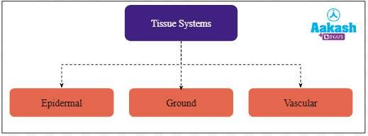

Dermal Tissue
Dermal tissue forms the outermost covering of the plant, called the epidermis. In stems and leaves, the dermal tissue is covered by a waxy cuticle that prevents water loss due to transpiration . In the leaf, some minute openings called stomata (singular: stoma) in the cuticle layer allow
gas exchange. Each stoma is covered by a pair of bean-shaped guard cell that regulates its opening and closing.

Unlike stems and leaves, the dermal layer of root gives rise to some lateral outgrowths called root hairs. Trichomes, or small hairlike or spikey outgrowths of epidermal tissue, sometimes found on the stem and leaves, aid in defense against herbivores.
In woody plants, the epidermis breaks into a multi-layered periderm (or bark) as secondary growth allows plants to grow in girth. The periderm functions as the plant’s first line of defense, protecting it from injury, dehydration, fire, and pathogens.

Ground Tissue
The ground tissue system is considered to include all the tissues except epidermis and vascular bundles. It is derived from the ground meristem. It forms the major part of the plant body. It is composed of simple tissues like parenchyma, collenchyma and sclerenchyma. The ground tissue system is a multilayered structure. The parenchymatous cells with intercellular spaces will be thin walled.
This tissue system is primarily responsible for providing support to the plant and may also help in storage of food. The ground tissue system in the roots stores food which is responsible for the formation of edible roots like carrots and turnips. Chlorenchyma cells in the ground tissues are responsible for the preparation of food, since chloroplast is present in them. The hypodermis protects the underlying layers and the endodermal cells, cortical cells and medullary rays contribute to conduction of water and nutrients.
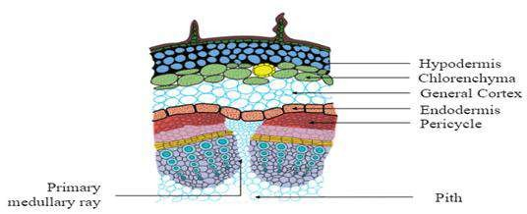

Ground tissues are made of three cell types :Parenchyma,
Collenchyma and Sclerenchyma

Parenchyma
They are spherical, elongated cells with a thin and flex cell wall but lack a secondary cell wall. Parenchy
ible primary ma cells are
totipotent and thus have the ability to divide and differentiate into any cell. They are the main component of young plant organs. They are found in almost all cell types, such as in mesophyll cells, stem cortex, and pith, and as a component of vascular tissues.

Collenchyma
Like parenchyma cells, collenchyma also lacks secondary cell walls but is thicker than primary cell walls. As their cells are long and thin, they can stretch and elongate, which helps them provide structural support in growing regions of the stem and leaves.

Sclerenchyma
Unlike other ground tissues, sclerenchyma has secondary cell walls composed of lignin. This tough substance is the primary component of wood. So, these cells cannot stretch and are dead. They provide structural support to the plant.

Vascular Tissue
It includes two types of conducting tissues: xylem and phloem. Xylem conducts water and minerals from the roots to different plant parts and plays a role in structural support in the stem. On the other hand, phloem transports organic compounds from the site of photosynthesis to other parts of the plant. The xylem and phloem form the vascular bundle in roots, stems, and roots.
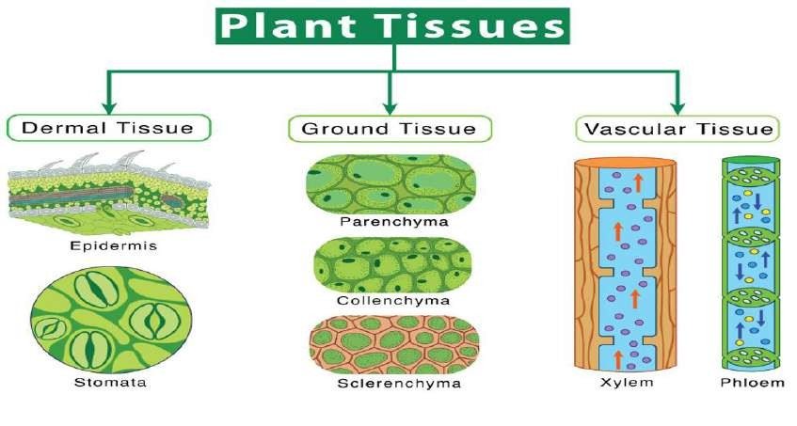

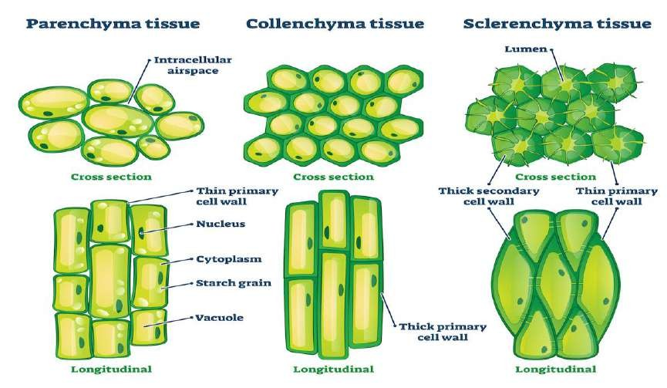
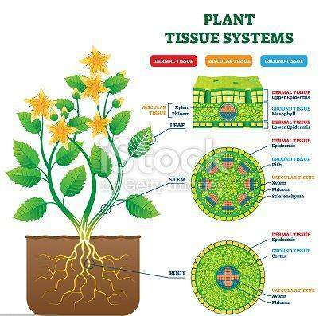

The ground tissue system is mainly composed of hypodermis, cortical cells, endodermis, pericycle , conjunctive tissue and pith.

Hypodermis
Hypodermis lies under the epidermis of dicot stems. It may occasionally be regarded as the cortex's outermost layer. Sclerenchyma cells or collenchyma cells may make up the hypodermis. These cells can often be modified to provide additional structural support or to store food or water.
Cortex
Large, thin-walled parenchyma cells from the ground tissue system make up the majority of the cortex, which exhibits little to no structural differentiation. Cortical cells of young plants have chloroplast and can prepare food. Cells of the cortex also contain leucoplast for storage of starch grains. The cortex is responsible for transportation of water and salts from the root hairs to the centre of the root.
Endodermis
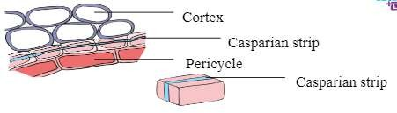
Endodermis is made up of tightly packed live cells. It has casparian strips (lignified thickenings) on both the tangential and radial walls. The casparian strip is water- resistant and helps the plant to regulate the amount of water and minerals it absorbs from the soil. Although an endodermis with casparian strip is always found in roots, it can also be found in the stems and leaves of some vascular plants.

Casparian strip
Some endodermal cells will have no casparian strips and those cells are called passage cells or transfusion cells. These cells allow radial diffusion of water and minerals through the endodermis.
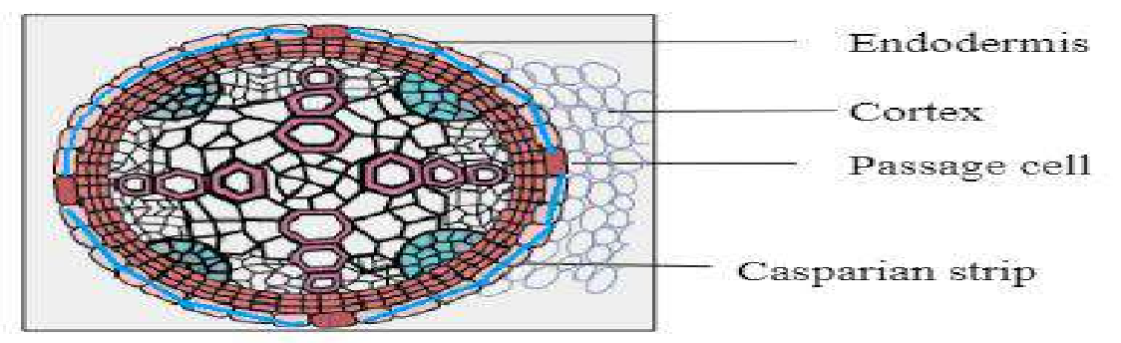
Passage cells

Pericycle
The pericycle is a few layers thick and is formed of thick walled parenchymatous cells. The pericycle lies between the endodermis and the vascular tissues. The formation of lateral roots initiates from the pericycle. It also helps in secondary growth by forming the cork cambium.
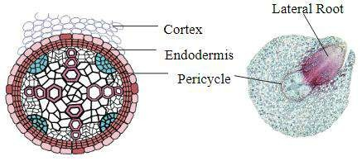

Pericycle and formation of lateral roots
Conjunctive tissue
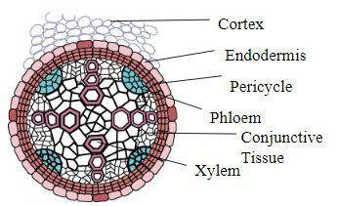
Parenchymatous cells which lie between the xylem and the phloem are called conjunctive tissues. If the tissue is parenchymatous, conjunctive cells serve as food storage units. After getting sclerified, they offer mechanical strength.

Conjunctive tissue
Pith
Pith is usually made of parenchyma cells and is located at the centre of the root. The pith is small and inconspicuous in dicot roots but it is large and conspicuous in monocot roots. The size of the pith varies in the anatomy of dicots and monocots.

.

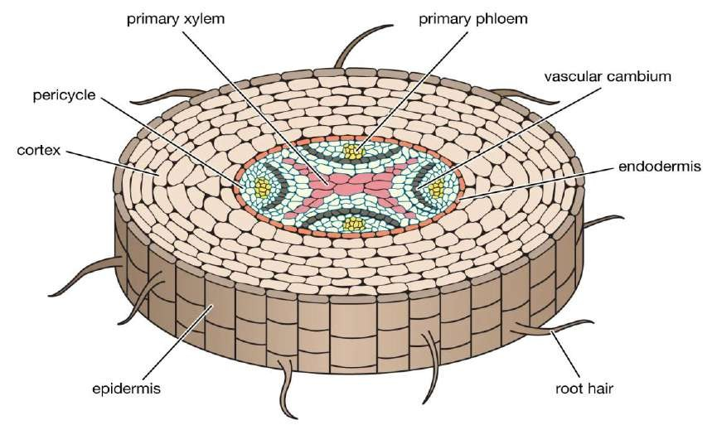
Root tissue
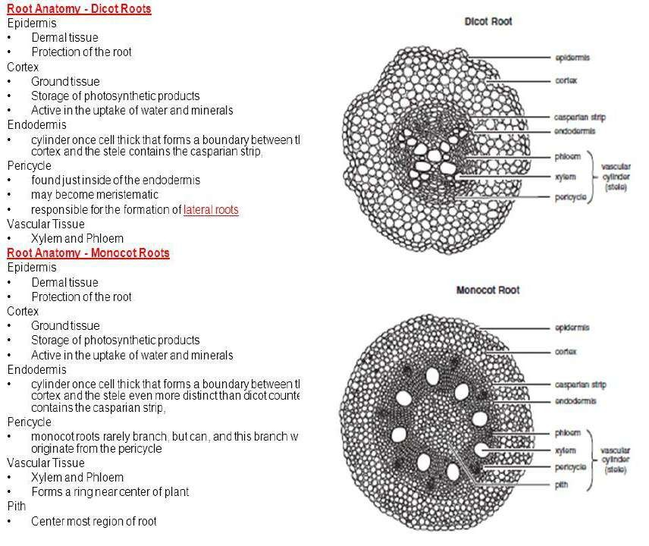

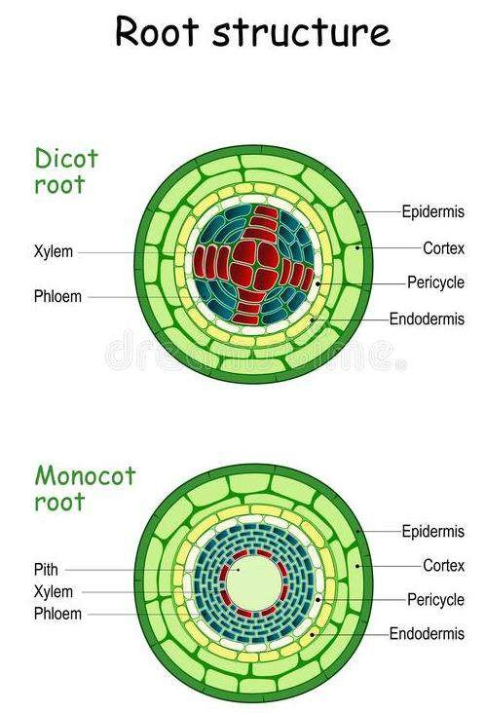

Comparative between roots tissue

